Teuthology issue:-

Hi ,
->Actually, I have one teuthology- node, 3 target nodes and one paddles /pulpit node.
->In teuthology-node, I created two extra users apart from existing Ubuntu user. They are 1)teuthology 2)teuthworker.
->When we run the teuthology-suite then total no. of jobs of a particular suite are queued by teuthology user and then those queued jobs were executed across target nodes when we ran worker_start from teuthworker user.
->After running jobs are successful. Then the results we can see in pulpito dashboard.
when I ran teuthology-suite , it was running successfully and jobs are queued . I was observing test-suite results on dashboard.
->Jobs were queued but not running. For running jobs first I ran worker_start plana 1 from teuthworker user. Second I ran teuthology-suite from Ubuntu user of teuthology-node.
->teuthworker try to take the suite of jobs but not running just finished with dead or finished with fail.

Note:-
Before running the teuthology-suite we have start the teuthology-worker as shown below.[first start worker in one window then immediately in next window you will run suite ]
teuthworker@teuthology-node:~$ ls
archive bin create_nodes.py src teuthology.yaml
teuthworker@teuthology-node:~$ cd bin/
teuthworker@teuthology-node:~/bin$ ls
worker_start
teuthworker@teuthology-node:~/bin$ vi worker_start (worker_start is a script file, it will run teuthology-worker utility)
teuthworker@teuthology-node:~$ worker_start plana 1
plana 1
Starting 1 workers for plana
teuthworker@teuthology-node:~$ 2015-08-20 23:47:13,344.344 INFO:teuthology.repo_utils:Fetching from upst
ream into /home/teuthworker/src/teuthology_master
2015-08-20 23:47:15,024.024 INFO:teuthology.repo_utils:Resetting repo at /home/teuthworker/src/teutholog
y_master to branch master
2015-08-20 23:47:15,032.032 INFO:teuthology.repo_utils:Bootstrapping /home/teuthworker/src/teuthology_ma
ster
2015-08-20 23:47:22,067.067 INFO:teuthology.repo_utils:Bootstrap exited with status 0
2015-08-20 23:47:22,068.068 INFO:teuthology.repo_utils:Fetching from upstream into /home/teuthworker/src
/ceph-qa-suite_master
2015-08-20 23:47:23,733.733 INFO:teuthology.repo_utils:Resetting repo at /home/teuthworker/src/ceph-qa-s
uite_master to branch master
2015-08-20 23:47:55,978.978 INFO:teuthology.worker:Reserved job 2113
2015-08-20 23:47:55,979.979 INFO:teuthology.worker:Config is: branch: master
description: teuthology/no-ceph/{clusters/single.yaml distros/ubuntu14.04.yaml tasks/teuthology.yaml}
email: sivar@vedams.com
kernel: {kdb: true, sha1: distro}
last_in_suite: false
machine_type: plana
name: ubuntu-2015-08-20_23:47:37-teuthology-master-distro-basic-plana
nuke-on-error: true
os_type: ubuntu
os_version: '14.04'
overrides:
admin_socket: {branch: master}
ceph:
conf:
mon: {debug mon: 20, debug ms: 1, debug paxos: 20}
osd: {debug filestore: 20, debug journal: 20, debug ms: 1, debug osd: 20}
log-whitelist: [slow request]
sha1: aeb80d03e1148f9c07849e2dc7b48c8d50bb440a
ceph-deploy:
branch: {dev: master}
conf:
client: {log file: /var/log/ceph/ceph-$name.$pid.log}
mon: {debug mon: 1, debug ms: 20, debug paxos: 20, osd default pool size: 2}
install:
ceph: {sha1: aeb80d03e1148f9c07849e2dc7b48c8d50bb440a}
workunit: {sha1: aeb80d03e1148f9c07849e2dc7b48c8d50bb440a}
owner: scheduled_ubuntu@teuthology-node
priority: 1000
roles:
- [mon.0, client.0]
sha1: aeb80d03e1148f9c07849e2dc7b48c8d50bb440a
suite: teuthology
suite_branch: master
tasks:
- {ansible.cephlab: null}
- {clock.check: null}
- {tests: null}
teuthology_branch: cuttlefish
tube: plana
verbose: false

2015-08-20 23:48:06,975.975 INFO:teuthology.repo_utils:Fetching from upstream into /home/teuthworker/src
/teuthology_cuttlefish
2015-08-20 23:48:08,614.614 INFO:teuthology.repo_utils:Resetting repo at /home/teuthworker/src/teutholog
y_cuttlefish to branch cuttlefish
2015-08-20 23:48:08,620.620 INFO:teuthology.repo_utils:Bootstrapping /home/teuthworker/src/teuthology_cu
ttlefish
2015-08-20 23:48:09,595.595 INFO:teuthology.repo_utils:Bootstrap exited with status 0
2015-08-20 23:48:09,596.596 INFO:teuthology.repo_utils:Fetching from upstream into /home/teuthworker/src
/ceph-qa-suite_master
2015-08-20 23:48:11,202.202 INFO:teuthology.repo_utils:Resetting repo at /home/teuthworker/src/ceph-qa-s
uite_master to branch master
2015-08-20 23:48:11,217.217 INFO:teuthology.worker:Creating archive dir /home/teuthworker/archive/ubuntu
-2015-08-20_23:47:37-teuthology-master-distro-basic-plana/2113
2015-08-20 23:48:11,218.218 INFO:teuthology.worker:Running job 2113
2015-08-20 23:48:11,229.229 INFO:teuthology.worker:Job archive: /home/teuthworker/archive/ubuntu-2015-08
-20_23:47:37-teuthology-master-distro-basic-plana/2113
2015-08-20 23:48:11,229.229 INFO:teuthology.worker:Job PID: 13640
2015-08-20 23:48:11,230.230 INFO:teuthology.worker:Running with watchdog
DEBUG:teuthology.run:Config:
archive_path: /home/teuthworker/archive/ubuntu-2015-08-20_23:47:37-teuthology-master-distro-basic-plan
a/2113
branch: master
description: teuthology/no-ceph/{clusters/single.yaml distros/ubuntu14.04.yaml tasks/teuthology.yaml}
email: sivar@vedams.com
job_id: '2113'
kernel:
kdb: true
sha1: distro
last_in_suite: false
machine_type: plana
name: ubuntu-2015-08-20_23:47:37-teuthology-master-distro-basic-plana
nuke-on-error: true
os_type: ubuntu
os_version: '14.04'
overrides:
admin_socket:
branch: master
ceph:
conf:
mon:
debug mon: 20
debug ms: 1
debug paxos: 20
osd:
debug filestore: 20
debug journal: 20
debug ms: 1
debug osd: 20
log-whitelist:
- slow request
sha1: aeb80d03e1148f9c07849e2dc7b48c8d50bb440a
ceph-deploy:
branch:
dev: master
conf:
client:
log file: /var/log/ceph/ceph-$name.$pid.log
mon:
debug mon: 1
debug ms: 20
debug paxos: 20
osd default pool size: 2
install:
ceph:
sha1: aeb80d03e1148f9c07849e2dc7b48c8d50bb440a
workunit:
sha1: aeb80d03e1148f9c07849e2dc7b48c8d50bb440a
owner: scheduled_ubuntu@teuthology-node
priority: 1000
roles:
- - mon.0
- client.0
sha1: aeb80d03e1148f9c07849e2dc7b48c8d50bb440a
suite: teuthology
suite_branch: master
suite_path: /home/teuthworker/src/ceph-qa-suite_master
tasks:
- ansible.cephlab: null
- clock.check: null
- tests: null
teuthology_branch: cuttlefish
tube: plana
verbose: false
worker_log: /home/teuthworker/archive/worker_logs/worker.plana.13106
INFO:teuthology.run_tasks:Running task internal.lock_machines...
INFO:teuthology.task.internal:Locking machines...
ERROR:teuthology.run_tasks:Saw exception from tasks
Traceback (most recent call last):
File "/home/teuthworker/src/teuthology_cuttlefish/teuthology/run_tasks.py", line 27, in run_tasks
manager.__enter__()
File "/usr/lib/python2.7/contextlib.py", line 17, in __enter__
return self.gen.next()
File "/home/teuthworker/src/teuthology_cuttlefish/teuthology/task/internal.py", line 56, in lock_machi
nes
machines = lock.list_locks(ctx)
File "/home/teuthworker/src/teuthology_cuttlefish/teuthology/lock.py", line 58, in list_locks
success, content, _ = ls.send_request('GET', ls._lock_url(ctx))
File "/home/teuthworker/src/teuthology_cuttlefish/teuthology/lockstatus.py", line 12, in send_request
resp, content = http.request(url, method=method, body=body, headers=headers)
File "/home/teuthworker/src/teuthology_cuttlefish/virtualenv/local/lib/python2.7/site-packages/httplib
2/__init__.py", line 1608, in request
(response, content) = self._request(conn, authority, uri, request_uri, method, body, headers, redire
ctions, cachekey)
File "/home/teuthworker/src/teuthology_cuttlefish/virtualenv/local/lib/python2.7/site-packages/httplib
2/__init__.py", line 1350, in _request
(response, content) = self._conn_request(conn, request_uri, method, body, headers)
File "/home/teuthworker/src/teuthology_cuttlefish/virtualenv/local/lib/python2.7/site-packages/httplib
2/__init__.py", line 1278, in _conn_request
raise ServerNotFoundError("Unable to find the server at %s" % conn.host)
ServerNotFoundError: Unable to find the server at paddlessiva.front.sepia.ceph.com
DEBUG:teuthology.run_tasks:Exception was not quenched, exiting: ServerNotFoundError: Unable to find the
server at paddlessiva.front.sepia.ceph.com
Traceback (most recent call last):
File "/home/teuthworker/src/teuthology_cuttlefish/virtualenv/bin/teuthology", line 9, in <module>
load_entry_point('teuthology==0.0.1', 'console_scripts', 'teuthology')()
File "/home/teuthworker/src/teuthology_cuttlefish/teuthology/run.py", line 186, in main
nuke(ctx, log, ctx.lock)
File "/home/teuthworker/src/teuthology_cuttlefish/teuthology/nuke.py", line 376, in nuke
for target, hostkey in ctx.config['targets'].iteritems():
KeyError: 'targets'

ubuntu@teuthology-node:~/teuthology$ ./virtualenv/bin/teuthology-suite -s teuthology -c master -e sivar@v
edams.com -f basic -t cuttlefish -m plana -k distro -d ubuntu
2015-08-20 23:47:37,787.787 INFO:teuthology.suite:kernel sha1: distro
2015-08-20 23:47:40,147.147 INFO:teuthology.suite:ceph sha1: aeb80d03e1148f9c07849e2dc7b48c8d50bb440a
2015-08-20 23:47:42,160.160 INFO:teuthology.suite:ceph version: 9.0.2-1474-gaeb80d0-1trusty
2015-08-20 23:47:43,169.169 INFO:teuthology.suite:teuthology branch: cuttlefish
2015-08-20 23:47:44,098.098 INFO:teuthology.suite:ceph-qa-suite branch: master
2015-08-20 23:47:44,100.100 INFO:teuthology.repo_utils:Fetching from upstream into /home/ubuntu/src/ceph-q
a-suite_master
2015-08-20 23:47:46,999.999 INFO:teuthology.repo_utils:Resetting repo at /home/ubuntu/src/ceph-qa-suite_ma
ster to branch master
2015-08-20 23:47:47,041.041 WARNING:teuthology.suite:No machines found with machine_type plana!
2015-08-20 23:47:47,044.044 INFO:teuthology.suite:Suite teuthology in /home/ubuntu/src/ceph-qa-suite_maste
r/suites/teuthology generated 25 jobs (not yet filtered)
2015-08-20 23:47:47,133.133 INFO:teuthology.suite:Scheduling teuthology/ceph/{clusters/single.yaml distros
/rhel.yaml tasks/teuthology.yaml}
Job scheduled with name ubuntu-2015-08-20_23:47:37-teuthology-master-distro-basic-plana and ID 2106
2015-08-20 23:47:48,202.202 INFO:teuthology.suite:Scheduling teuthology/no-ceph/{clusters/single.yaml dist
ros/baremetal.yaml tasks/teuthology.yaml}
Job scheduled with name ubuntu-2015-08-20_23:47:37-teuthology-master-distro-basic-plana and ID 2107
2015-08-20 23:47:49,294.294 INFO:teuthology.suite:Scheduling teuthology/rgw/{distros/rhel7.0.yaml tasks/s3
tests-fastcgi.yaml}
Job scheduled with name ubuntu-2015-08-20_23:47:37-teuthology-master-distro-basic-plana and ID 2108
2015-08-20 23:47:50,530.530 INFO:teuthology.suite:Scheduling teuthology/no-ceph/{clusters/single.yaml dist
ros/rhel7.0.yaml tasks/teuthology.yaml}
Job scheduled with name ubuntu-2015-08-20_23:47:37-teuthology-master-distro-basic-plana and ID 2109
2015-08-20 23:47:51,563.563 INFO:teuthology.suite:Scheduling teuthology/rgw/{distros/ubuntu12.04.yaml task
s/s3tests-fcgi.yaml}
Job scheduled with name ubuntu-2015-08-20_23:47:37-teuthology-master-distro-basic-plana and ID 2110
2015-08-20 23:47:52,614.614 INFO:teuthology.suite:Scheduling teuthology/no-ceph/{clusters/single.yaml dist
ros/ubuntu12.04.yaml tasks/teuthology.yaml}
Job scheduled with name ubuntu-2015-08-20_23:47:37-teuthology-master-distro-basic-plana and ID 2111
2015-08-20 23:47:53,912.912 INFO:teuthology.suite:Scheduling teuthology/rgw/{distros/ubuntu14.04.yaml task
s/s3tests-fastcgi.yaml}
Job scheduled with name ubuntu-2015-08-20_23:47:37-teuthology-master-distro-basic-plana and ID 2112
2015-08-20 23:47:54,987.987 INFO:teuthology.suite:Scheduling teuthology/no-ceph/{clusters/single.yaml dist
ros/ubuntu14.04.yaml tasks/teuthology.yaml}
Job scheduled with name ubuntu-2015-08-20_23:47:37-teuthology-master-distro-basic-plana and ID 2113
2015-08-20 23:47:56,047.047 INFO:teuthology.suite:Scheduling teuthology/rgw/{distros/vps_centos6.5.yaml ta
sks/s3tests-fcgi.yaml}
Job scheduled with name ubuntu-2015-08-20_23:47:37-teuthology-master-distro-basic-plana and ID 2114
2015-08-20 23:47:57,094.094 INFO:teuthology.suite:Scheduling teuthology/no-ceph/{clusters/single.yaml dist
ros/vps.yaml tasks/teuthology.yaml}
Job scheduled with name ubuntu-2015-08-20_23:47:37-teuthology-master-distro-basic-plana and ID 2115
2015-08-20 23:47:58,136.136 INFO:teuthology.suite:Scheduling teuthology/rgw/{distros/vps_debian7.yaml task
s/s3tests-fastcgi.yaml}
Job scheduled with name ubuntu-2015-08-20_23:47:37-teuthology-master-distro-basic-plana and ID 2116
2015-08-20 23:47:59,192.192 INFO:teuthology.suite:Scheduling teuthology/no-ceph/{clusters/single.yaml dist
ros/vps_centos6.5.yaml tasks/teuthology.yaml}
Job scheduled with name ubuntu-2015-08-20_23:47:37-teuthology-master-distro-basic-plana and ID 2117
2015-08-20 23:48:00,243.243 INFO:teuthology.suite:Scheduling teuthology/ceph/{clusters/single.yaml distros
/ubuntu.yaml tasks/teuthology.yaml}
Job scheduled with name ubuntu-2015-08-20_23:47:37-teuthology-master-distro-basic-plana and ID 2118
2015-08-20 23:48:01,287.287 INFO:teuthology.suite:Scheduling teuthology/rgw/{distros/vps_rhel6.5.yaml task
s/s3tests-fcgi.yaml}
Job scheduled with name ubuntu-2015-08-20_23:47:37-teuthology-master-distro-basic-plana and ID 2119
2015-08-20 23:48:02,323.323 INFO:teuthology.suite:Scheduling teuthology/no-ceph/{clusters/single.yaml dist
ros/vps_debian7.yaml tasks/teuthology.yaml}
Job scheduled with name ubuntu-2015-08-20_23:47:37-teuthology-master-distro-basic-plana and ID 2120
2015-08-20 23:48:03,365.365 INFO:teuthology.suite:Scheduling teuthology/rgw/{distros/rhel7.0.yaml tasks/s3
tests-fcgi.yaml}
Job scheduled with name ubuntu-2015-08-20_23:47:37-teuthology-master-distro-basic-plana and ID 2121
2015-08-20 23:48:04,415.415 INFO:teuthology.suite:Scheduling teuthology/no-ceph/{clusters/single.yaml dist
ros/vps_rhel6.4.yaml tasks/teuthology.yaml}
Job scheduled with name ubuntu-2015-08-20_23:47:37-teuthology-master-distro-basic-plana and ID 2122
2015-08-20 23:48:05,463.463 INFO:teuthology.suite:Scheduling teuthology/rgw/{distros/ubuntu12.04.yaml task
s/s3tests-fastcgi.yaml}
Job scheduled with name ubuntu-2015-08-20_23:47:37-teuthology-master-distro-basic-plana and ID 2123
2015-08-20 23:48:06,509.509 INFO:teuthology.suite:Scheduling teuthology/no-ceph/{clusters/single.yaml dist
ros/vps_rhel6.5.yaml tasks/teuthology.yaml}
Job scheduled with name ubuntu-2015-08-20_23:47:37-teuthology-master-distro-basic-plana and ID 2124
2015-08-20 23:48:07,565.565 INFO:teuthology.suite:Scheduling teuthology/rgw/{distros/ubuntu14.04.yaml task
s/s3tests-fcgi.yaml}
Job scheduled with name ubuntu-2015-08-20_23:47:37-teuthology-master-distro-basic-plana and ID 2125
2015-08-20 23:48:08,654.654 INFO:teuthology.suite:Scheduling teuthology/no-ceph/{clusters/single.yaml dist
ros/vps_rhel7.0.yaml tasks/teuthology.yaml}
Job scheduled with name ubuntu-2015-08-20_23:47:37-teuthology-master-distro-basic-plana and ID 2126
2015-08-20 23:48:09,713.713 INFO:teuthology.suite:Scheduling teuthology/rgw/{distros/vps_centos6.5.yaml ta
sks/s3tests-fastcgi.yaml}
Job scheduled with name ubuntu-2015-08-20_23:47:37-teuthology-master-distro-basic-plana and ID 2127
2015-08-20 23:48:10,773.773 INFO:teuthology.suite:Scheduling teuthology/no-ceph/{clusters/single.yaml dist
ros/vps_ubuntu14.04.yaml tasks/teuthology.yaml}
Job scheduled with name ubuntu-2015-08-20_23:47:37-teuthology-master-distro-basic-plana and ID 2128
2015-08-20 23:48:11,831.831 INFO:teuthology.suite:Scheduling teuthology/rgw/{distros/vps_debian7.yaml task
s/s3tests-fcgi.yaml}
Job scheduled with name ubuntu-2015-08-20_23:47:37-teuthology-master-distro-basic-plana and ID 2129
2015-08-20 23:48:12,901.901 INFO:teuthology.suite:Scheduling teuthology/rgw/{distros/vps_rhel6.5.yaml task
s/s3tests-fastcgi.yaml}
Job scheduled with name ubuntu-2015-08-20_23:47:37-teuthology-master-distro-basic-plana and ID 2130
2015-08-20 23:48:13,964.964 INFO:teuthology.suite:Suite teuthology in /home/ubuntu/src/ceph-qa-suite_maste
r/suites/teuthology scheduled 25 jobs.
2015-08-20 23:48:13,964.964 INFO:teuthology.suite:Suite teuthology in /home/ubuntu/src/ceph-qa-suite_maste
r/suites/teuthology -- 0 jobs were filtered out.
Job scheduled with name ubuntu-2015-08-20_23:47:37-teuthology-master-distro-basic-plana and ID 2131
2015-08-20 23:48:14,993.993 INFO:teuthology.suite:Test results viewable at http://paddlessiva.front.sepia.
ceph.com/ubuntu-2015-08-20_23:47:37-teuthology-master-distro-basic-plana/

>Here worker not running the jobs . Its giving three errors.
1)saw exception from tasks of suite
2)server paddlessiva .front.sepia.ceph.com not found.[i.e, paddles server was not found]
3)key error: ‘targets’

>I checked paddles server is pinging from teuthology node or not. It was pinging. Paddles server also running successfully.
But why it was showing server not found error ?

>It was giving key Error: ‘targets’ [The teuthology- worker was not recognized ‘targets’ section targets.yaml file. That is the reason worker don’t login into targets to execute jobs. But I didn’t understand why the teuthology-worker not recognizing ‘targets’ section?]
ubuntu@teuthology-node:~/teuthology/examples$ ls
3node_ceph.yaml 3node_rgw.yaml parallel_example.yaml targets.yaml
ubuntu@teuthology-node:~/teuthology/examples$ vi targets.yaml

targets:
target1: ssh-rsa AAAAB3NzaC1yc2EAAAADAQABAAABAQDWPD+bXHBZcWcyqB2XQEpoJHoPi5UQKJNsqI2DGIVgLzWrM5I3L4T0C
92KC6ug5fRthzANJI2TqiA8jZq2G42xkuw2aTZ2BuXQZvY1PF5MRUg+fJ4lSOYMi0fxBGp3YpFxlcG+fKmmmlW3OhaxLLZORbd33y6TJ
4uBf6x91DEXZo3rax7ciZaw63TMJJ/aEDD3gId6svx/Dexc8MlgqewylRL/gJN9INV7lospQsOZlX0PxKHmU9d5Aob4FvjHnATDDE6Hx
r71yb+Wq7ui/08mjq5Zn6QJxTcK9nXEnWyCw7wrOAyj1BM5+10t26Bh7iJ9s/rVy3q1XRdD6n71eaMl
target2: ssh-rsa AAAAB3NzaC1yc2EAAAADAQABAAABAQDTX8NRn3PjnZ2ByrWX/RqOYOv2vpDGv532qzWtWAhq4why0s/g3Y6C4
MTt/LsQuPi3wmsoPcac1r9+/oXPs64btixRUf/GJ1Tn8c5GAp0aXPmnWfhkKxBm29aEdR8P56FFZEyN2mhLd/S7rqvW6b93WouXUNdX0
ee5fpqBt0elaF/Lq7CTas8LeV+MrWX1Jy/+NlWSuPH53XBSn6/Ur1j7irkmG8Wt1M+nyt5NUZG3Pm9u7xE3+DqBh6YXK7GiI/W5nEH26
Lsr3WA2tYiZDMeLs50UVATGc6tQgP1s+spvfH0YXEMIbMkIrvVL3pakreizslZSk9egaBEytmflMLpR
target3: ssh-rsa AAAAB3NzaC1yc2EAAAADAQABAAABAQC18tVdXHRC1beD5NEoWUDDj39iGfZfxA5b3s3A53QM3WRfHpxUIC0ZS
Ku63hW6xAUMzVbkYoadzBG1Clur5h1szDo/Acz8Jknh9BNNmPm4uQgmLY+S73OJlURaAo2AmiVYkEocw3L5JmMlNijSk7G5M1UiEK/Ub
d1zHi0Rv8oRf8xWrRiWBh2l+nZqYJZCIpn2YT8xXqBy3e+3ptvzdtdgKDeL9+LPX+RR+kobXYDtrJR3EvTFNeseNvL31ZRfeOfwYkpr6
BhbXN6lloY/AgqG+mg2RGA996eWQpW2LuoEQI9346335Sd7fBrR2JqfO7XLPCaobKtP6MHFHAg91Vkl

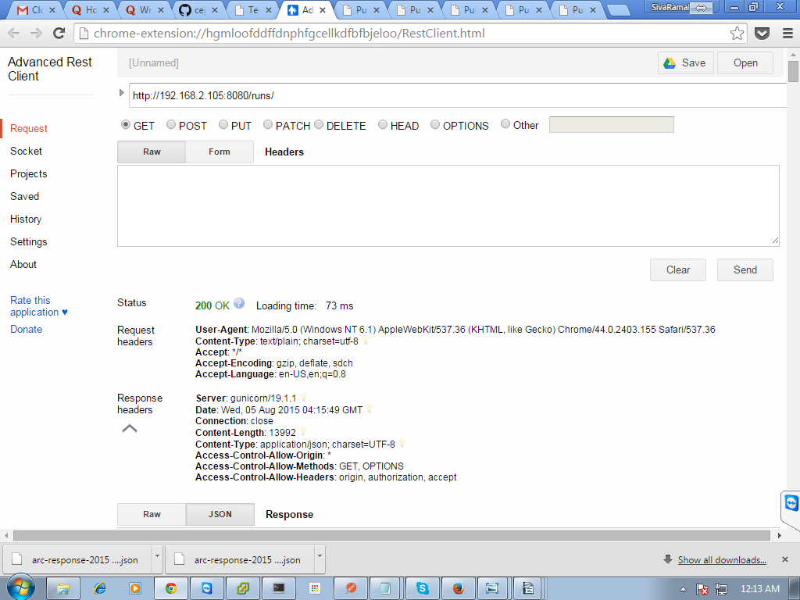

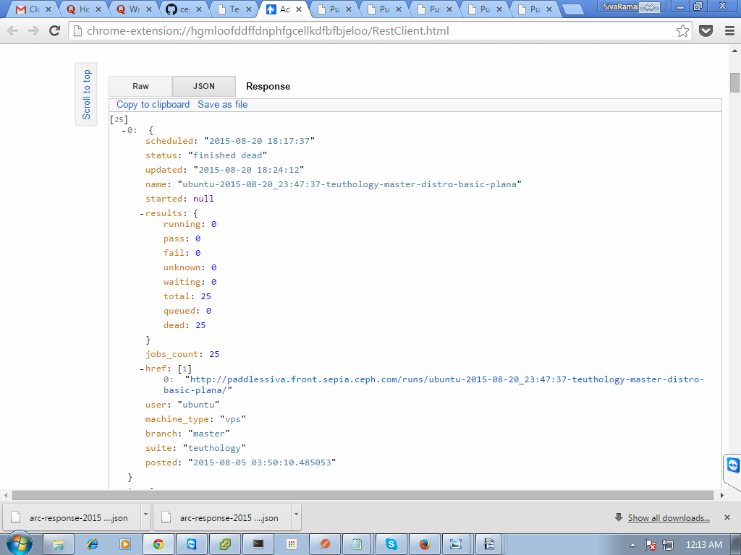

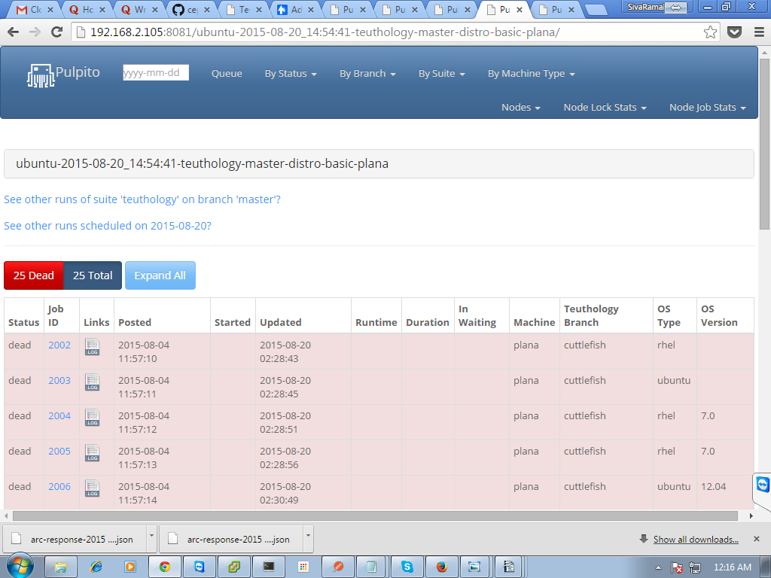

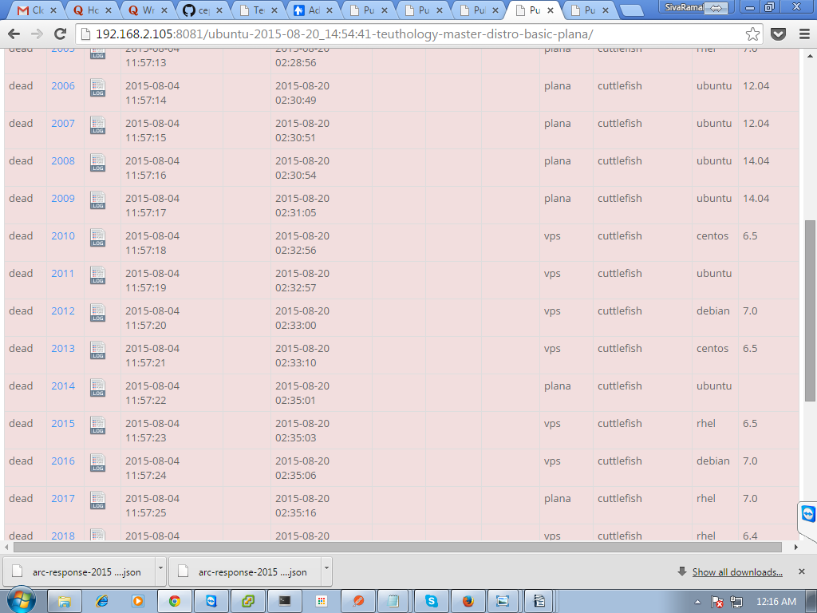

----------->>This was giving the dashboard result like above.
Andwhen I was checked for whether targets having lock are not, it shows the result as the targets were locked.
ubuntu@teuthology-node:~/teuthology$ ./virtualenv/bin/teuthology-lock --list --owner ubuntu@teuthology-node

[
{
"is_vm": false,
"locked": true,
"locked_since": "2015-07-29 01:29:41.138589",
"locked_by": "ubuntu@teuthology-node",
"up": true,
"mac_address": null,
"name": "target1.front.sepia.ceph.com",
"os_version": "14.04",
"machine_type": null,
"vm_host": null,
"os_type": "ubuntu",
"arch": "x86_64",
"ssh_pub_key": "ssh-rsa AAAAB3NzaC1yc2EAAAADAQABAAABAQDWPD+bXHBZcWcyqB2XQEpoJHoPi5UQKJNsqI2DGIVg
LzWrM5I3L4T0C92KC6ug5fRthzANJI2TqiA8jZq2G42xkuw2aTZ2BuXQZvY1PF5MRUg+fJ4lSOYMi0fxBGp3YpFxlcG+fKmmmlW3Ohax
LLZORbd33y6TJ4uBf6x91DEXZo3rax7ciZaw63TMJJ/aEDD3gId6svx/Dexc8MlgqewylRL/gJN9INV7lospQsOZlX0PxKHmU9d5Aob4
FvjHnATDDE6Hxr71yb+Wq7ui/08mjq5Zn6QJxTcK9nXEnWyCw7wrOAyj1BM5+10t26Bh7iJ9s/rVy3q1XRdD6n71eaMl",
"description": null
},
{
"is_vm": false,
"locked": true,
"locked_since": "2015-07-29 01:29:41.047502",
"locked_by": "ubuntu@teuthology-node",
"up": true,
"mac_address": null,
"name": "target2.front.sepia.ceph.com",
"os_version": "14.04",
"machine_type": null,
"vm_host": null,
"os_type": "ubuntu",
"arch": "x86_64",
"ssh_pub_key": "ssh-rsa AAAAB3NzaC1yc2EAAAADAQABAAABAQDTX8NRn3PjnZ2ByrWX/RqOYOv2vpDGv532qzWtWAhq
4why0s/g3Y6C4MTt/LsQuPi3wmsoPcac1r9+/oXPs64btixRUf/GJ1Tn8c5GAp0aXPmnWfhkKxBm29aEdR8P56FFZEyN2mhLd/S7rqvW
6b93WouXUNdX0ee5fpqBt0elaF/Lq7CTas8LeV+MrWX1Jy/+NlWSuPH53XBSn6/Ur1j7irkmG8Wt1M+nyt5NUZG3Pm9u7xE3+DqBh6YX
K7GiI/W5nEH26Lsr3WA2tYiZDMeLs50UVATGc6tQgP1s+spvfH0YXEMIbMkIrvVL3pakreizslZSk9egaBEytmflMLpR",
"description": null
},
{
"is_vm": false,
"locked": true,
"locked_since": "2015-07-29 01:29:41.094408",
"locked_by": "ubuntu@teuthology-node",
"up": true,
"mac_address": null,
"name": "target3.front.sepia.ceph.com",
"os_version": "14.04",
"machine_type": null,
"vm_host": null,
"os_type": "ubuntu",
"arch": "x86_64",
"ssh_pub_key": "ssh-rsa AAAAB3NzaC1yc2EAAAADAQABAAABAQC18tVdXHRC1beD5NEoWUDDj39iGfZfxA5b3s3A53QM
3WRfHpxUIC0ZSKu63hW6xAUMzVbkYoadzBG1Clur5h1szDo/Acz8Jknh9BNNmPm4uQgmLY+S73OJlURaAo2AmiVYkEocw3L5JmMlNijS
k7G5M1UiEK/Ubd1zHi0Rv8oRf8xWrRiWBh2l+nZqYJZCIpn2YT8xXqBy3e+3ptvzdtdgKDeL9+LPX+RR+kobXYDtrJR3EvTFNeseNvL3
1ZRfeOfwYkpr6BhbXN6lloY/AgqG+mg2RGA996eWQpW2LuoEQI9346335Sd7fBrR2JqfO7XLPCaobKtP6MHFHAg91Vkl",
"description": null
}

I tried different ways to solve this issue.
Can anyone give any suggestion to me regarding this issue?

